Asteroids(Homework 4)
Tutorial 8

Specification
- A player-controlled ship can be moved around using the arrow keys or WSAD but remains on the screen.
- The ship should be able to fire bullet style missiles for a “shoot-em-up” style gameplay loop.
- Asteroids randomly spawn on the right of the screen without overlap and fly straight across.
- The background is like homework 3 and uses scrolling background layers to create a parallax mountain scene which creates the illusion of the ship moving fast.
- Structs or classes should be used to organize the code base for the project.
- Display and update appropriate text on the screen.

Technical design
The technical design documents included are:
- Decomposition diagram outlining the relationship between the classes required
- Class diagrams showing the classes and some of the functions and variables used in each
- Flowchart with pseudocode

Game Manager

Int maxBackgroundLayers
Int maxAsteroids
Int maxBullets
Int totalNumberOfObjects
Int numberOfCollideableObjects
Game_Object* arrayOfObjects[]
Collideable_Objects arrayOfCollideableObjects[]
Float backgroundScrollSpeedArray[]
Bullet bulletPool[]
Background backgroundPool[]
Asteroid asteroidPool[]
Ship playerShip
RenderWindow window
Int windowWidth
Int windowHeight
String gameTitle
Float asteroid spawnTimer
Float asteroidBuffer
Event eventPoller
Clock gameClock
Time deltaTime
Input_Manger playerInputManager
Collision_Manager collisionManager
Enum gameState
{
START
PLAY
GAME OVER
}
Int score
Texture backgroundTextureArray[]
Texture shipTexture
Texture bulletTexture
Texture asteroidTexture
Font gameFont
Text startScreenText
Text GameOverText
Text playerStatsText
Int textSize
Vector2f textPosition

Void runGame
Void initializeGame
Void initializeWindow
Void initializeTextures
Void initializeFontAndText
Void initializeShip
Void initializeBackgrounds
Void initializeAsteroids
Void initializeBullets
Void initializeGameObjectArray
Void pollEvents
Void updateGame
Void updateGameObjects
Void updateBackground
Void updatePlayerStats
Void renderGame
Void renderGameObjects
Void renderStartScreen
Void renderEndScreen
Void renderPlayerStats
Void spawnAsteroids
Void fireBullet
Bool loadTexture

The game object class is a virtual inheritance class inherited by the objects of the game providing a polymorphic way to update, render and initialize the objects in the game.

Game_Object

Bool IsActive
Bool getIsActive
Void setIsActive
Void deactivate
Virtual void updateObject
Virtual void renderObject
Virtual void initializeObject

The collideable object class is a virtual class that is inherited by only the collideable objects in the game, for example bullets and asteroids. The class contains an enum used to define the kind of object as well as a bool flag to be activated and deactivated to help the collision manager work out if it needs to check collision against that object and what the outcome of that collision.
Collideable_Object

Enum typeOfObject
{
NORMAL_ASTEROID,
LARGE_ASTEROID,
SMALL_ASTEROID,
BULLET,
SHIP
}
Bool isCollideable
Void getIsCollideable
Void setCollideable
Void deactivateCollision
typeOfObject getType

Virtual FloatRect getBounds
Virtual Bool collisionCheck (FloatRect objectYouAreHitting)
Virtual void collisionOutcome(bool collisionFlag, typeOfObject objectType)

Ship : Collideable_Object, Game_Object

Sprite shipSprite
Vector2f shipPosition
Vecto2f shipVelocity
intRect shipRect
enum Direction
{
NORTH,
NORTH EAST,
EAST,
SOUTH EAST,
SOUTH,
SOUTH WEST,
WEST,
NORTH WEST,
STOPPED
}
float ShipSpeed
float shipScale
int maxHp
float shipRotation
int shipDamageTaken

Void setTexture
Void updateDirection
Vector2f getPosition
Int getShipHealth
Void scaleAndCenterOrigin
Void shipWindowBoundsCollision
Void shipTakeDamage

FloatRect getBounds override
Bool collisionCheck (FloatRect objectYouAreHitting) override
Void collisionOutcome (bool collisionFlag, typeOfObject objectType) override
void updateObject) override
void renderObject) override
void initializeObject) override

Bullet: Collideable_Object, Game_Object

Float bulletSpeed
Float bulletScale
Float animationSpeed
Float animationTimer
Sprite bulletSprite
Vector2f bulletVelocity
Float bull

Test plan

Input | Expected outcome | Observed outcome | Action taken
Asteroid’s sprite is animated and has a texture | The sprite should cycle through 32 frame animations at around 60 frames per second | The sprites texture was off and was showing lots of blank space around each frame | Changed the sprite size constant variable in the code to better reflect the actual size of the asteroid texture on the sprite sheet
The player attempts to move using WSAD or the arrow keys | The ship moves around the screen in the direction indicated. | The ship moves around the screen in the direction indicated | Used similar code from homework 3 however added an input class that allows for the adding of further control schemes like controller or joystick in future.
A bullet collides with an asteroid sprite | The asteroid should take damage and be destroyed if it reaches 0 health. The bullet should be deactivated and removed from the render/update loop. | The bullet was correctly deactivated, but the asteroid was not removed once it reached low health. | The asteroid spawn loop was not resetting the spawn timer so was being called every frame. The asteroids spawn function was also affecting all asteroids on the screen not just those that were not active.  Fixed the spawn asteroid function so that it now resets the spawn timer and correctly only affects non active asteroids.
The ship collides with an asteroid | The ship should take damage based on the kind of asteroid.  The asteroid should be deactivated from rendering and updating.  The player stats should be updated and output on screen. | The ship takes damage based on the asteroid.  The asteroid is removed from the update and rendering loop and is no longer able to collide with anything.  The player stats were being updated but would output as one large string and grew each frame that the update function was called. | The player stats update function was using a string stream that wasn’t clearing each frame so each time the update function was called a new string would be added to the old string creating a long string and game breaking lag.  I added a line of code to clear the string stream before updating the new health value into it.
The ship reaches 0 health | The game state changed to game over and the end screen is displayed with the players’ final score and instructions to end the application. | The game state changed to game over and displayed the correct information with updated score | No action required
Space bar was pressed by the player | If the game is currently in the “playing” state, the ship should fire a bullet that moves to the right of the screen based on the player’s current position.  Else nothing should happen | Nothing happened when space bar was pressed on the start screen or end screen.  When pressed during the play state a missile would fire from the ship’s current location moving in an east direction.  The missile sprite was very small and needed to be scaled relative to the window | Added a new function to the bullet class that scaled the size of the sprite relative to the size of the window like the ship class.  Added this new function to the initialize function call.
Asteroid or bullet leaves the current render window bounds | The asteroid or bullet is deactivated and removed from the update and render loops and is no longer able to collide with anything. | The asteroid was removed from the update and render loop and no longer had collision.  They are left in the pool for reuse by the spawn and fire functions. | No action required.

GiT commit log
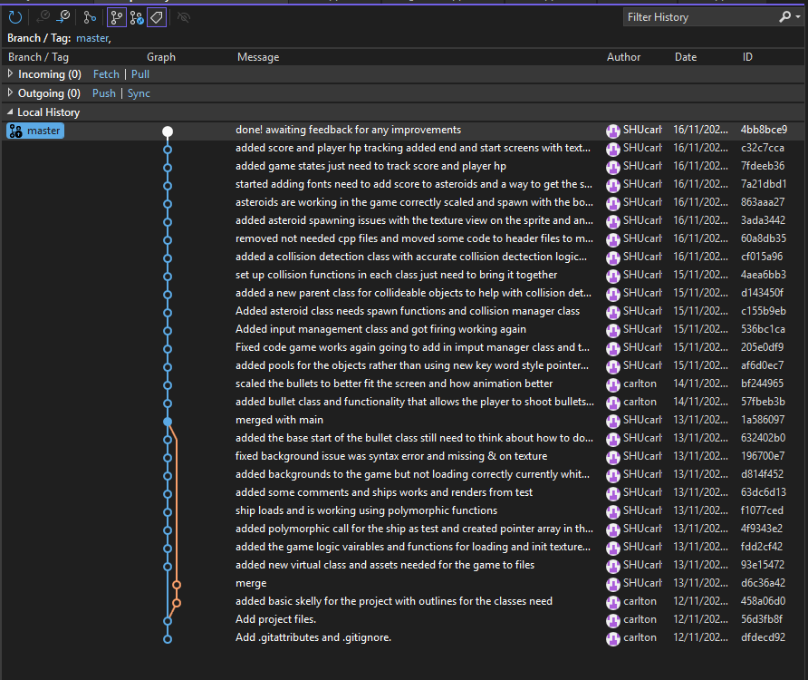

Schedule

Task | Estimated Hrs | Actual Hrs
Spec | 0.25 | 0.25
Design | 0.5 | 0.25
Implement | 3 | 2.5
Debug and test | 0.25 | 3.5
Slack | 1 | 0
total | 5 | 6.5

